Git tips images to lrn:

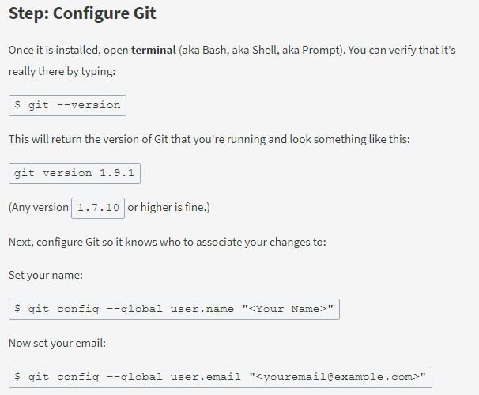

Step: Create a Repository(in pc using **command-line interface (CLI)**)

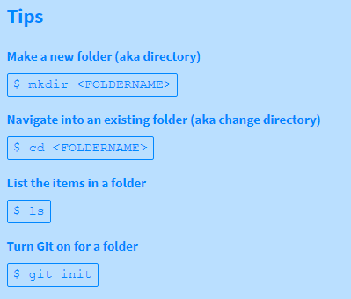

## 3) Commit To It

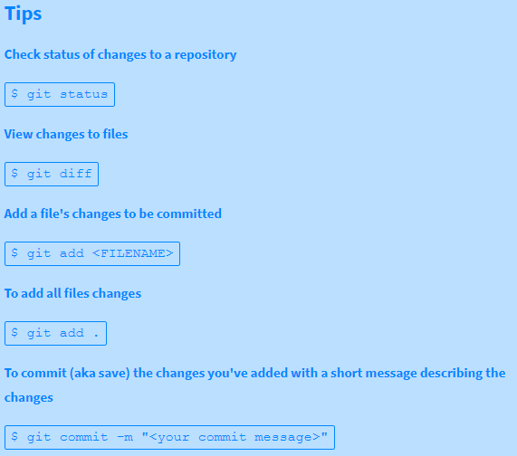

## 4) GitHubbin(Create a GitHub account, add username to your Git config.)

## 5) Remote Control

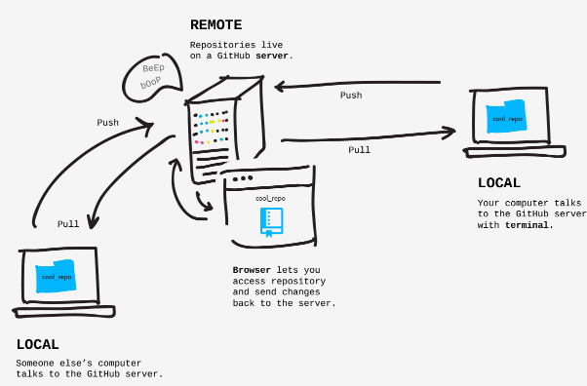

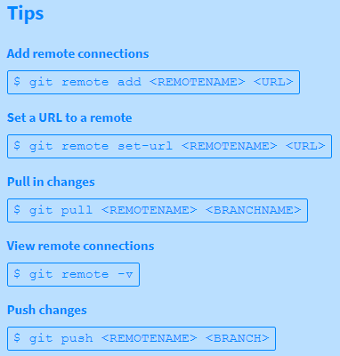

**6)Forks And Clones**

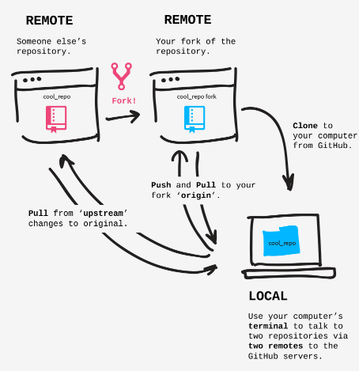

**Tips**

* **Add remote connections**
* $ git remote add <REMOTENAME> <URL>
* **View remote connections**
* $ git remote -v

## 7) Branches Aren't Just For Birds

## 

## 8)Pull Never Out Of Date

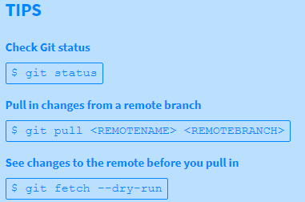

## 10)Requesting You Pull Please

